Revista de Comunicación y Salud, 2022, No.xx , pp-pp.



Edited by Cátedra de Comunicación y Salud

ISSN: 2173-1675

Submitted dd/mm/aaaa

Approved dd/mm/aaaa

Published dd/mm/aaaa

**TITLE OF THE ARTICLE**

# (TIMES NEW ROMAN 24, CAPITAL LETTERS, BOLD, CENTERED)

**Name and Surname of the first author (Times New Roman 12, bold, centered, single spaced):** University. Country. (Times New Roman 12, normal, centered, single spaced)[email@domain.com](mailto:email@domain.com)

(Times New Roman 12, normal, centered, single spaced).

**Name and surname of 2nd author (Times New Roman 12, bold, centered, single spaced):** University. Country. (Times New Roman 12, normal, centered, single **spaced).** [email@domain.com](mailto:email@domain.com%20)  (Times New Roman 12, normal, centered, single spaced as hyperlink).

and following authors...

**How to cite the article:** (APA NORM 7ª)

Surname, N., & Surname, N. (year). Title of article. *Revista de Comunicación y Salud*, ##, pp-pp. (Tahoma 12, justificado). <https://doi.org/10.35669/rcys.año.No.ID> (put by the editor)

***Funding.*** *A brief note on the sources of financing should be included if the article is linked to a research project financed by a public institution (national R&D&I plans, calls for proposals from universities, regional governments, etc.) or a private institution.*

## Abtract (Times New Roman 12, bold, justified, single-spaced, single spacing)

**Introduction:** normal text, normal text, normal text, normal text, normal text, normal text, normal text, normal text, normal text, normal text, normal text, normal text. **Methodology:** normal text, normal text, normal text, normal text, footnote, normal text, normal text, normal text, normal text, normal text, normal text, normal text, normal text, normal text, footnote, normal text, normal text, normal text, normal text. **Results:** normal text, normal text, normal text. **Discussion:** normal text, normal text, normal text, normal text, normal text, normal text, normal text, normal text, normal text, normal text, normal text, normal text, normal text, footnote, normal text, normal text, normal text, normal text, normal text, normal text, normal text, normal text, normal text, normal text. **Conclusions:** normal text, normal text, normal text, normal text, normal text, normal text, normal text, normal text, normal text, normal text, normal text, normal text. (Times New Roman, 12, normal, justified, single spacing)

**Key words:** (Times New Roman 12, bold, justified, single spaced)

word, word, word, word, word. (Times New Roman, 12, normal, justified, single spacing)

## INTRODUCTION (Times New Roman 12, bold, justified, single spacing)

Text (Times New Roman, 12, normal, justified, first line indent 0.5 cm, single spacing)

A direct quote within normal text of up to 40 words is enclosed in quotation marks. Not italicized. If the work has one or two authors, both last names are cited whenever they appear (Author and Author, Year). When there are more than two authors, only the last name of the first author is written, followed by et al.

Text text text text text text text text text text text text text text text text text text "quote quote quote quote quote quote quote quote quote quote quote quote quote quote quote" (Author, Year, p. XXX) text text text text text text text text text text text text text text text text text text.

A direct quote in normal text of more than 40 words: is not enclosed in quotation marks, the text is written in block format, on a separate line, with a left indent of 1.25 cm

Normal text, normal text, normal text, normal text, normal text, normal text, normal text, normal text, normal text, normal text...

Quote text, quote text, quote text, quote text, quote text, quote text, quote text, quote text, quote text, quote text, quote text, quote text, quote text. (Author et al., Year, pp. XXX-YYY)

Indirect quote in normal text. When paraphrasing or referring to ideas from another work, the page must be indicated (Author, Year, p. XXX). If the sentence includes the author's last name, only the date is written in parentheses (Year). If the author is not included in the sentence, the last name and date are written in parentheses (Author, Year).

Text text text text text text text text text text text text text text text text text text text text text text text text text text text text text (Author and Author, Year, pp. XXX-YYY) text text text text text.

### Second level title. (Arabic numbering, Times New Roman, 12, bold, justified, single spacing)

#### Third level and subsequent titles. (Arabic numbering, Times New Roman, 12, bold, left indent 1.25 cm, justified, single spacing)

## OBJECTIVES (Times New Roman 12, old, justified, single spacing)

Text (Times New Roman, 12, normal, justified, first line indent 0.5 cm, single spacing).

## METHODOLOGY (Times New Roman 12, bold, justified, single spacing)

Text (Times New Roman, 12, normal, justified, first line indent 0.5 cm, single spacing)

**Figure 1. (Times New Roman, 12, bold, left-aligned, single spacing)** *Title of the photograph. (Times New Roman, 12, italic, left-aligned, single spacing).*

¶

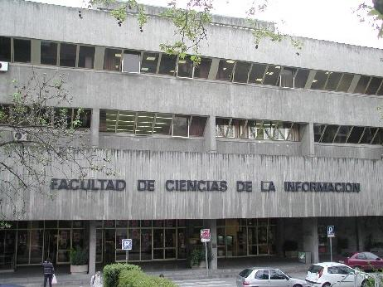

**Source: (Times New Roman, 12, bold, left-aligned, single spacing)** *authors. (Times New Roman, 12, italic, centered, single spacing).*

## RESULTS (Times New Roman 12, bold, justified, single spacing)

Text (Times New Roman, 12, normal, justified, first line indent 0.5 cm, single spacing)

## DISCUSSION (Times New Roman 12, bold, justified, single spacing)

Text (Times New Roman, 12, normal, justified, first line indent 0.5 cm, single spacing)

**Figure 2. (Times New Roman, 12, bold, centered, single spacing))** *Title of the graph. (Times New Roman, 12, italic, centered, single spacing)*

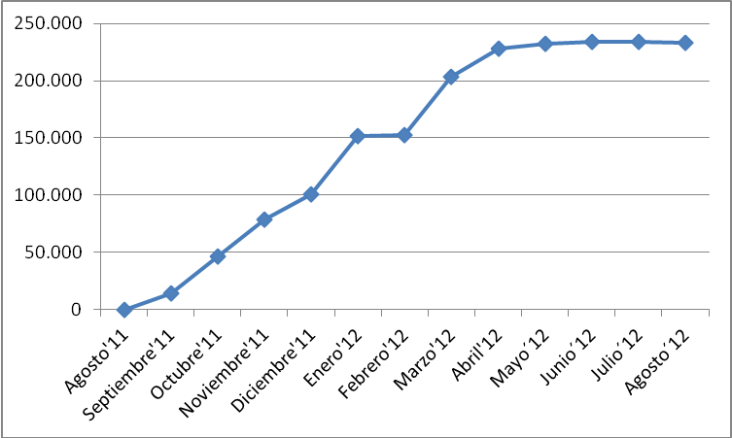

**Source: (Times New Roman, 12, bold, centered, single spacing)** *authors. (Times New Roman, 12, italic, centered, single spacing)*

Text (Times New Roman, 12, normal, justified, first line indent 0.5 cm, single spacing).

**Table 1. (Times New Roman 12, bold, justified, single spacing)** *Title of the table. (Times New Roman, 12, italic, centered, single spacing).*

|  |  |  |  |
| --- | --- | --- | --- |
| **Degrees** | **Pregnant** | **Abortions** | **Not pregnant** |
| Sector N | | | |
| 9 | 0 | 0 | 27 |
| 10 | 0 | 0 | 25 |
| 11 | 1 | 1 | 29 |
| **Total** | **1** | **1** | **81** |
| *Sector S* | | | |
| 9 | 2 | 3 | 20 |
| 10 | 4 | 6 | 17 |
| 11 | 8 | 12 | 15 |
| **Total** | **14** | **21** | **52** |

**Source: (Times New Roman, 12, bold, centered, single spacing)** *authors. (Times New Roman, 12, italic, centered, single spacing)*

The design of the tables should include all borders, with clearly defined columns and rows.

## CONCLUSIONS (Times New Roman 12, bold, justified, single spacing)

Text (Times New Roman, 12, normal, justified, first line indent 0.5 cm, single spacing)

## REFERENCES (APA 7th Edition). (Times New Roman 12, bold, justified, single spacing)

Text (Times New Roman, 12, normal, justified, hanging indent 0.5 cm, single spacing)

Text (Times New Roman, 12, normal, justified, hanging indent 0.5 cm, single spacing)

**AUTHOR CONTRIBUTIONS, FUNDING, AND ACKNOWLEDGMENTS**

**Conceptualization:** Last Name Last Name, First Name, Last Name Last Name, First Name, and Last Name Last Name, First Name. **Methodology:** Last Name Last Name, First Name, and Last Name Last Name, First Name. **Software:** Last Name Last Name, First Name. **Validation:** Last Name Last Name, First Name, and Last Name Last Name, First Name. **Formal Analysis:** Last Name Last Name, First Name, and Last Name Last Name, First Name. **Data Curation:** Last Name Last Name, First Name. **Writing – Original Draft Preparation:** Last Name Last Name, First Name. **Writing – Review and Editing:** Last Name Last Name, First Name. **Visualization:** Last Name Last Name, First Name. **Supervision:** Last Name Last Name, First Name. **Project Administration:** Last Name Last Name, First Name. **All authors have read and agreed to the published version of the manuscript:** Last Name Last Name, First Name.

**Funding**: This research did not receive / received external funding.

**Acknowledgments**: This text arises within the framework of a CONCILIUM project (931.791) of the Complutense University of Madrid, “Validation of communication models, companies, social networks and gender.”

**Conflict of Interest:** Text (Times New Roman, 12, normal, justified)If they exist.

### AUTHORS:

**Surname and first name of the authors 1 (Times New Roman, 12, bold, justified, single spacing)**

Affiliation

Brief Curriculum Vitae [no more than 120 words] (Times New Roman, 12, normal, justified, single spacing)

[email@domain.com](mailto:email@domain.com) on the next line: **IF THE AUTHOR HAS ANY PERSONAL IDENTIFIER LIKE ORCID, REDIRIS, RESEARCH GATE OR SIMILAR, IT WOULD GO HERE.**

**H-Index:**

**Orcid ID:**

**Scopus ID:**

**Google Scholar:**

**Research Gate:**

**Academia.edu:**

And so on with the following authors…

**Annex (Times New Roman 12, bold, justified, single spacing)**

Text (Times New Roman, 12, normal, justified, single spacing)